|  |
| --- |
| CS 1530 – SPRINT 1 DELIVERABLE |
| https://github.com/drb56/CS1530 |

|  |
| --- |
| David Bickford (drb56@pitt.edu)  Craig Kodman (cmk126@pitt.edu) **[SCRUM MASTER]**  Joe Meszar (jwm54@pitt.edu)  David Tsui (dat83@pitt.edu)  DUE DATE:  **9/29/2016** |

# USER STORIES

1. AS A **USER**, I WANT A **CHESSBOARD**, SO THAT I CAN **PLAY CHESS**.
2. AS A **USER**, I WANT **CHESS PIECES**, SO THAT I CAN **PLAY CHESS**.
3. AS A **USER**, I WANT TO MOVE MY **CHESS PIECES**, SO THAT I CAN **PLAY CHESS**.
4. AS A **USER**, I WANT TO **ABIDE BY THE UNITED STATES CHESS FEDERATION RULES**, SO THAT I CAN **PLAY CHESS**.
5. AS A **USER**, I WANT TO **HAVE A GRAPHICAL INTERFACE**, SO THAT I CAN **PLAY WITH A MOUSE**.
6. AS A **USER**, I WANT TO **HAVE BLACK AND WHITE CHESS PIECES**, SO THAT I CAN **PLAY CHESS**.
7. AS A **USER**, I WANT TO **BE ABLE TO CHOOSE MY TEAM COLOR**, SO THAT I CAN **PLAY AS EITHER BLACK OR WHITE**.
8. AS A **USER**, I WANT TO **MOVE CHESS PIECES USING A MOUSE CLICK**, SO THAT I CAN **PLAY CHESS INTERACTIVELY**.
9. AS A **USER**, I WANT TO **SAVE MY CHESS GAME IN ITS CURRENT STATE**, SO THAT I CAN **RESUME THE GAME AT A LATER TIME**.
10. AS A **USER**, I WANT **LOAD A SAVED CHESS GAME**, SO THAT I CAN **RESUME A PREVIOUSLY-PLAYED CHESS GAME**.

EXECUTED UNIT TESTS 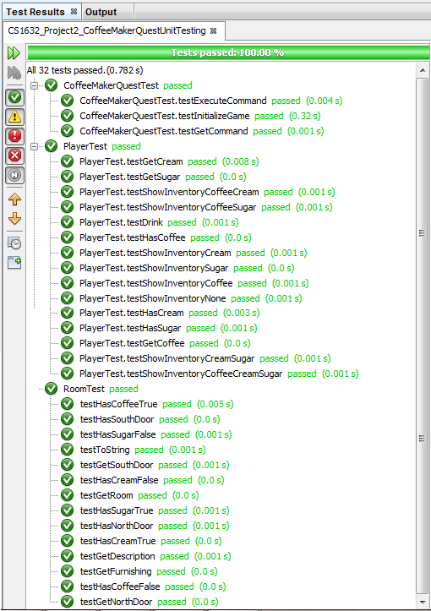

CODE COVERAGE

